ASSIGNMENT 5

Please follow below notices:
- Do it with your group
- Submit a package of Power BI file and report (in MS Word format, show process of your work in step-by-step, and give your comments on those figures). Name of files follows the structure of “ex5_group1.pbix”, “ex5_group1.docx”.
- This is a summary assignment, so do it as much as possible.
- Deadline of submission: before 23:00 October 14, 2022

Importing and modeling data
- Import data files into Power Query Editor and rename queries like:
Data file | Query name
CoolSchoolUniversityInstructorGatheredStudentInformation.xlsx | Survey Data
CoolSchoolUniversitySchoolSuppliedDataClassStart.xlsx | Demographic Data
CoolSchoolUniversityGradesPowerBIVersion.xlsx | AssignmentDIM  Grades

- In Grades query, keep the first four columns, remove null values in ClassID column. Add a conditional column Attended based on OfficeHoursAttended column, if OfficeHoursAttended get value null, Attended get value No; if OfficeHoursAttended get value 1, Attended get value Yes.
You get the data model like:
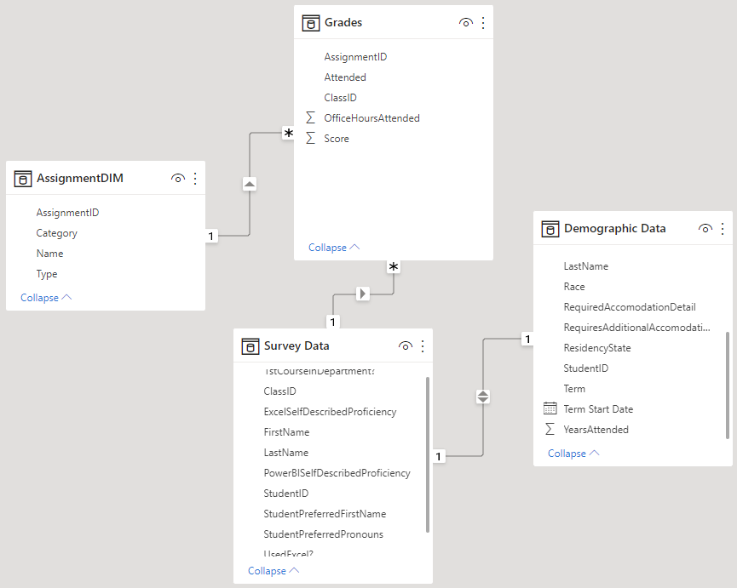

Visualizing data
- Create a map to see the number of students and their average score by residency states.
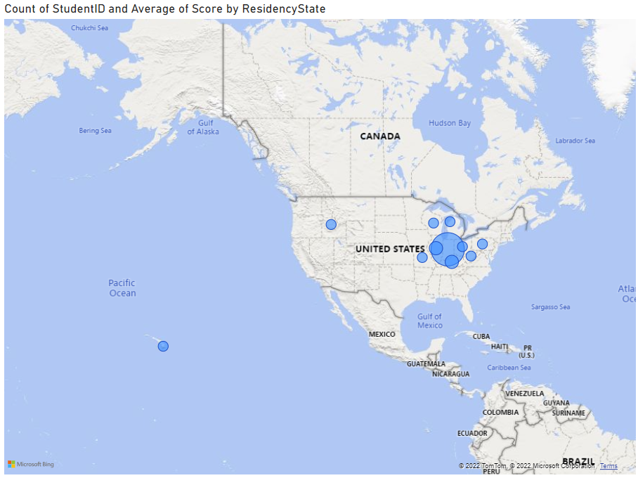
- Stacked bar and column charts
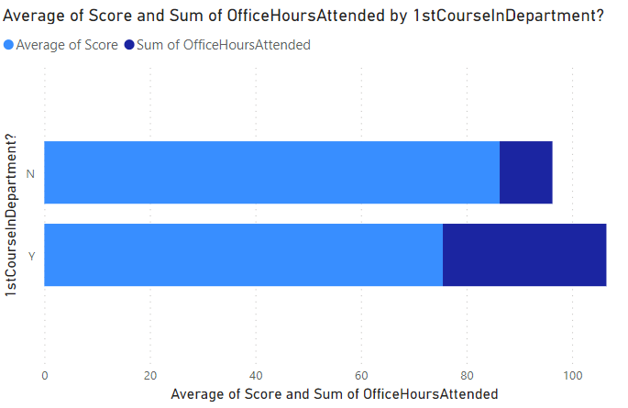
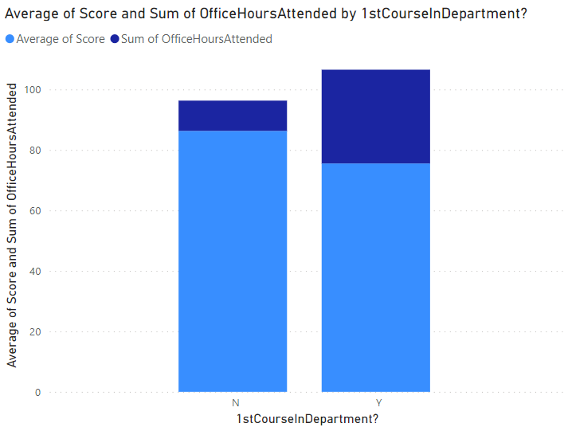
- Clustered bar and column charts
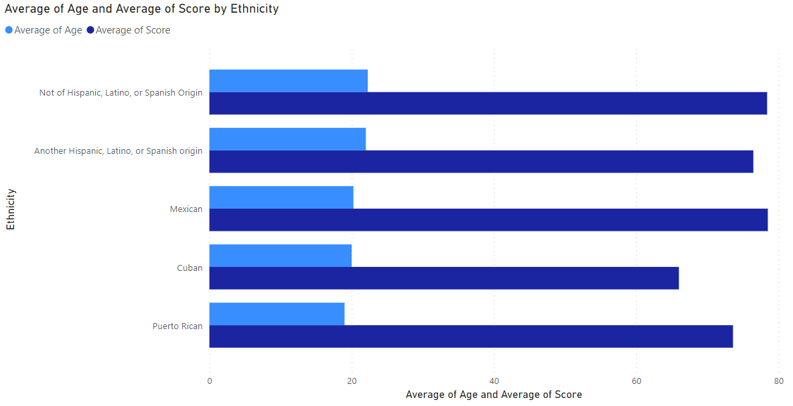
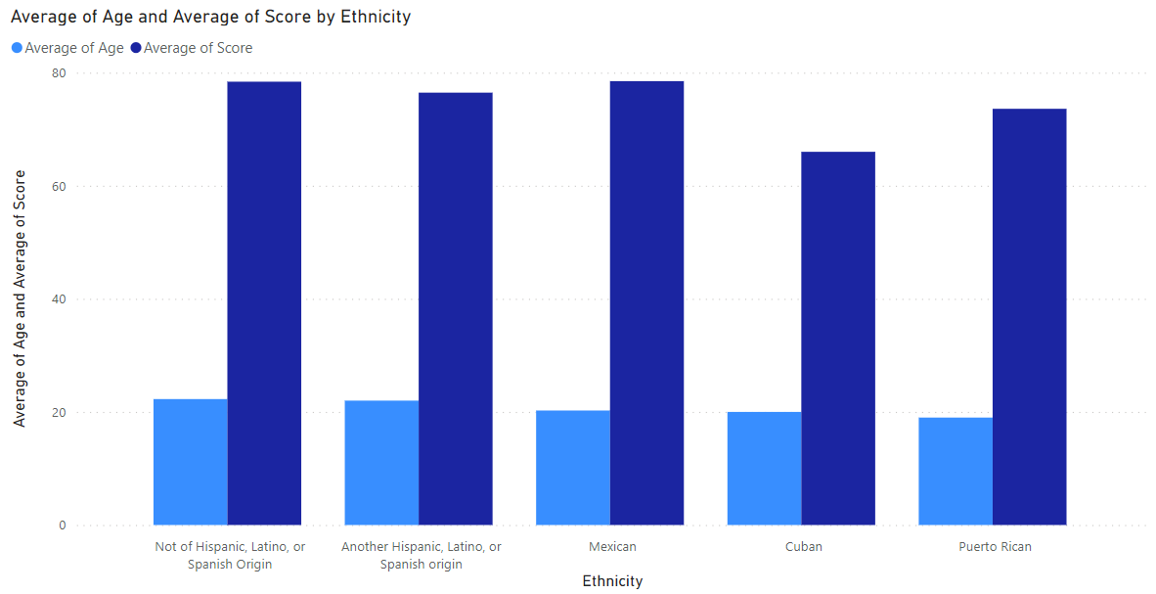
- 100% stacked bar and column charts
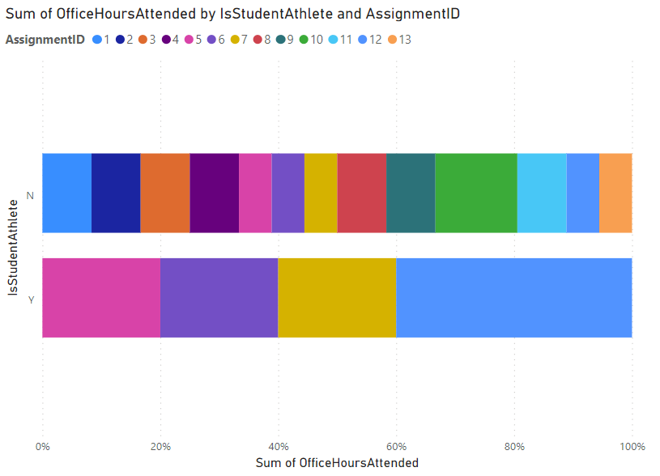
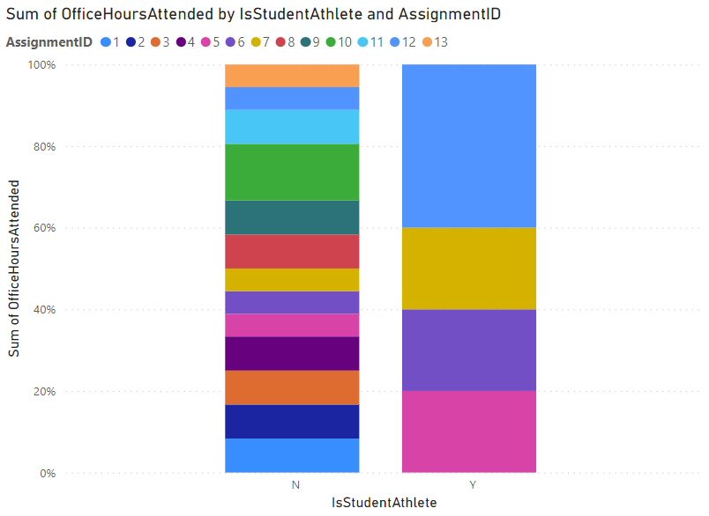
- Small multiples
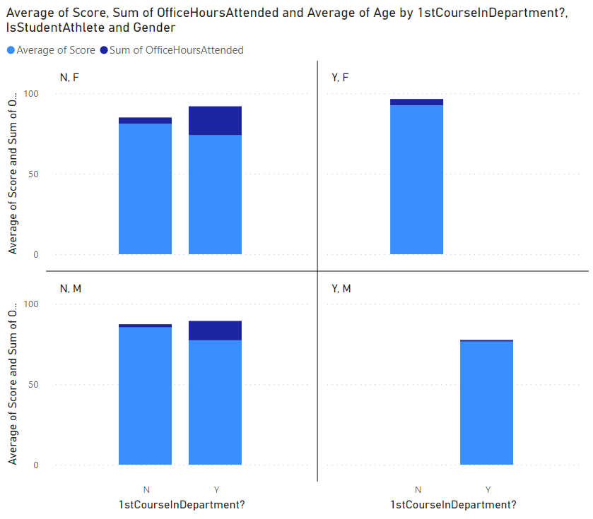
- Waterfall chart
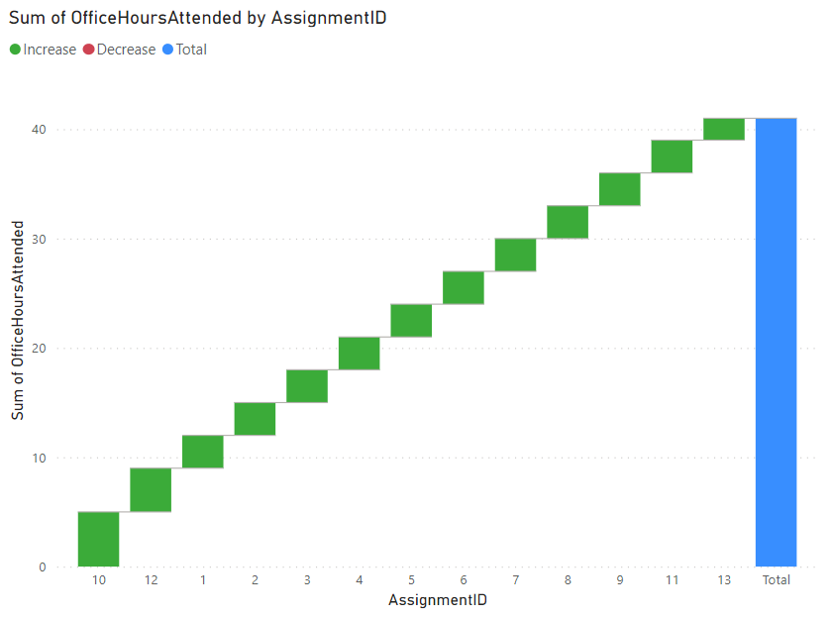
- Line chart
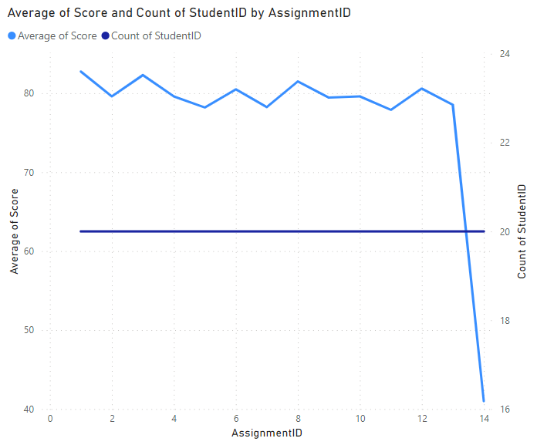
- Area chart
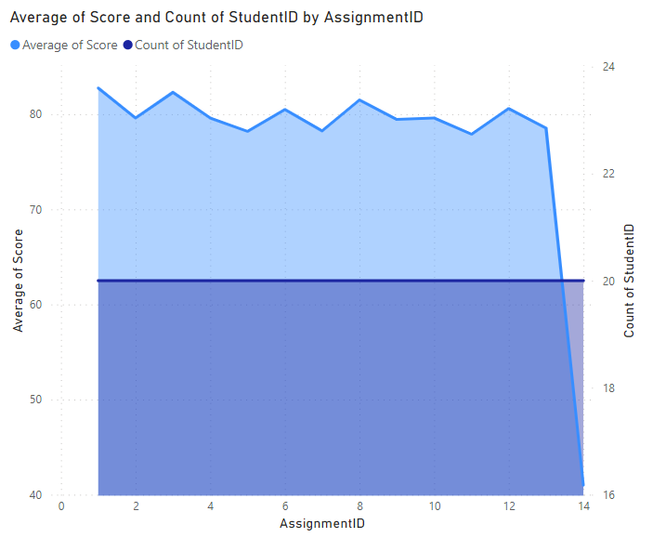
- Stacked area chart
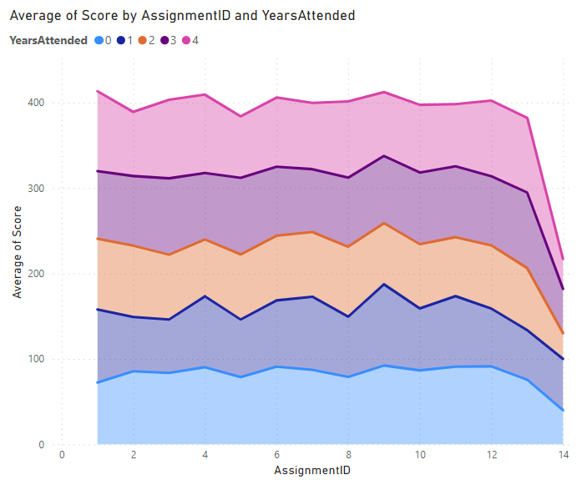
- Line and stacked column chart/ Clustered column chart
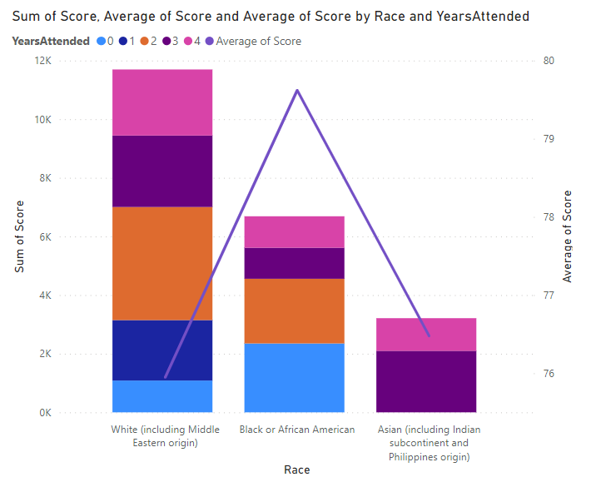
- Ribbon chart
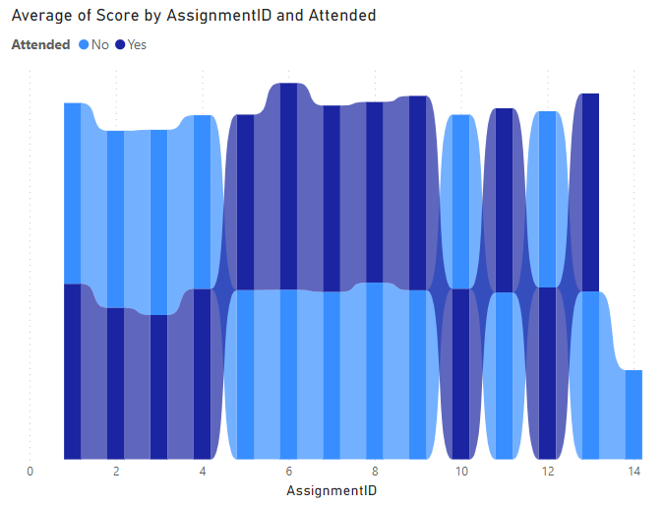
- Funnel chart
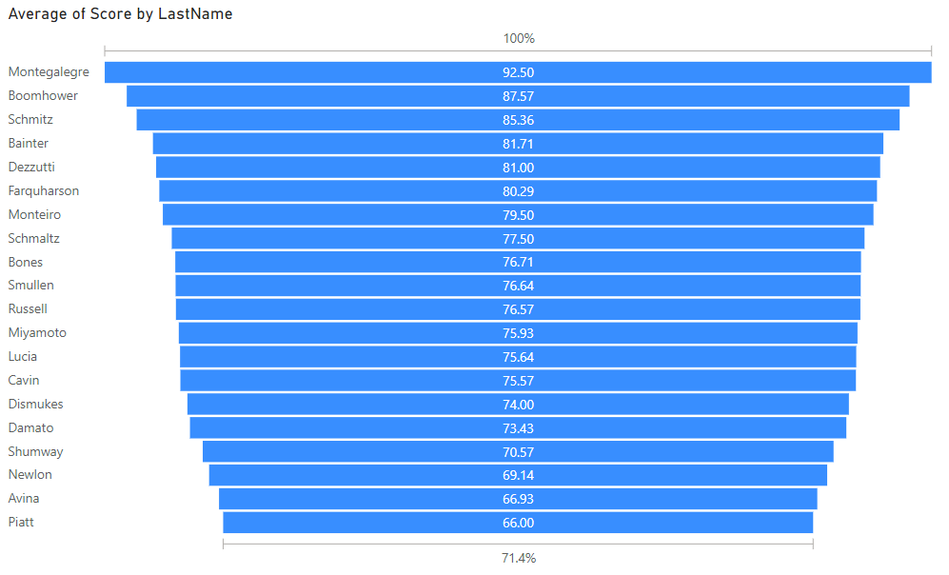
- Scatter chart
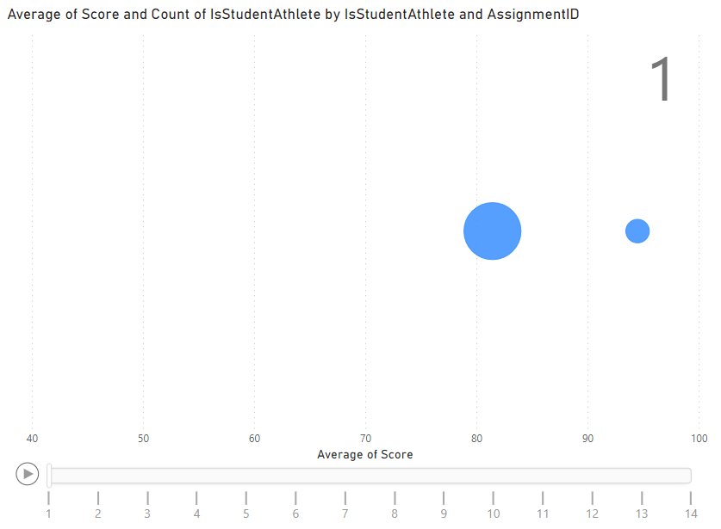
- Pie and donut chart: Which charts are more effective?
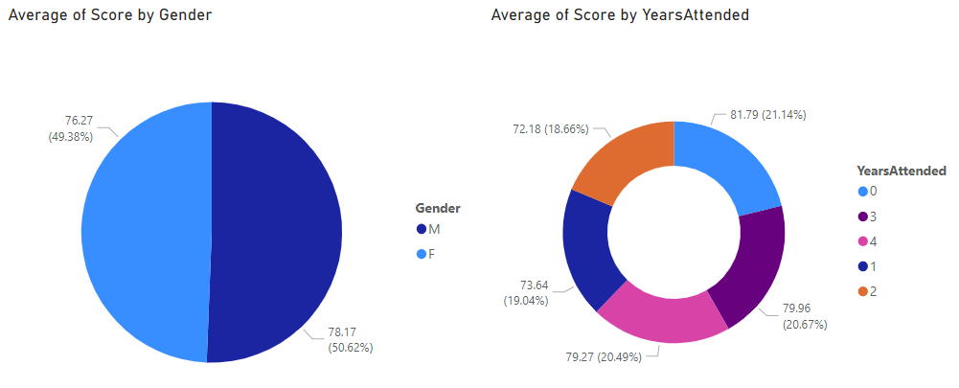
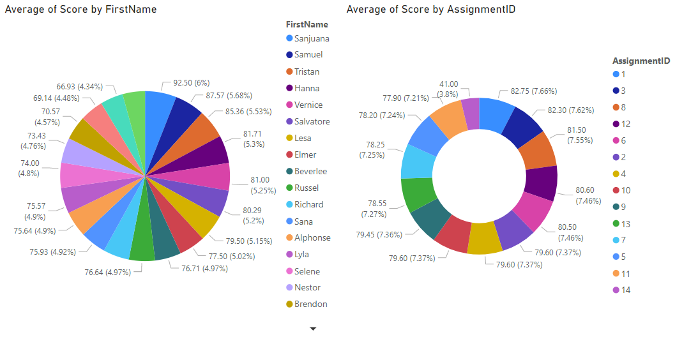
- Treemap
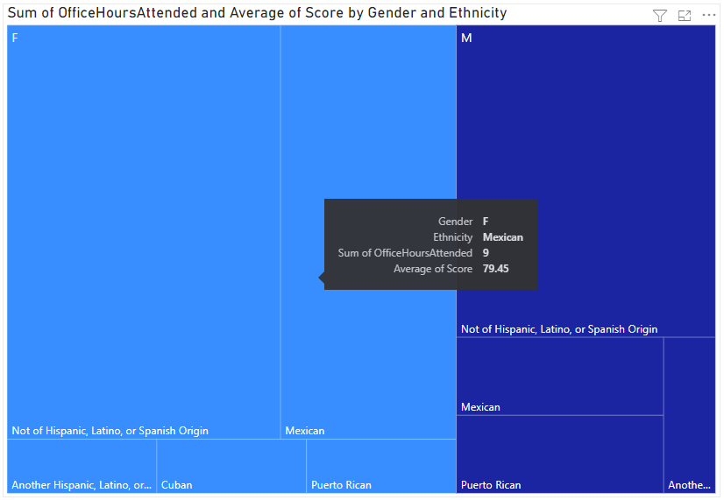
- Gauge
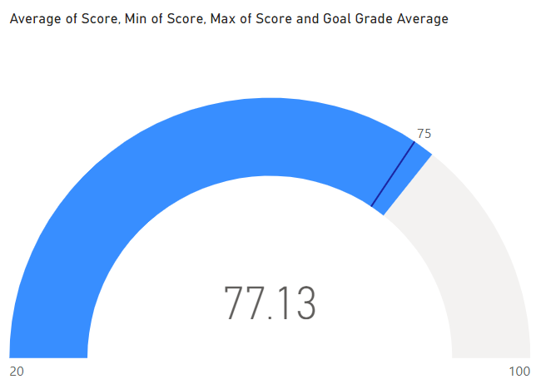
- Card/Multi-row card
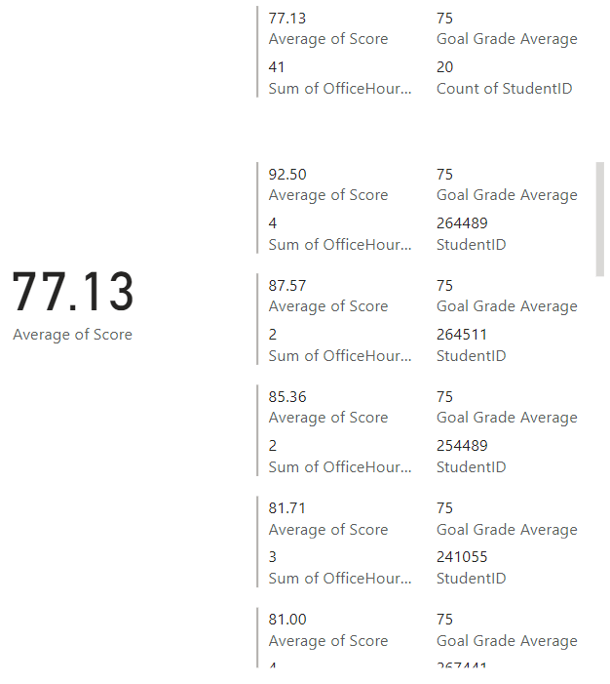
- KPI
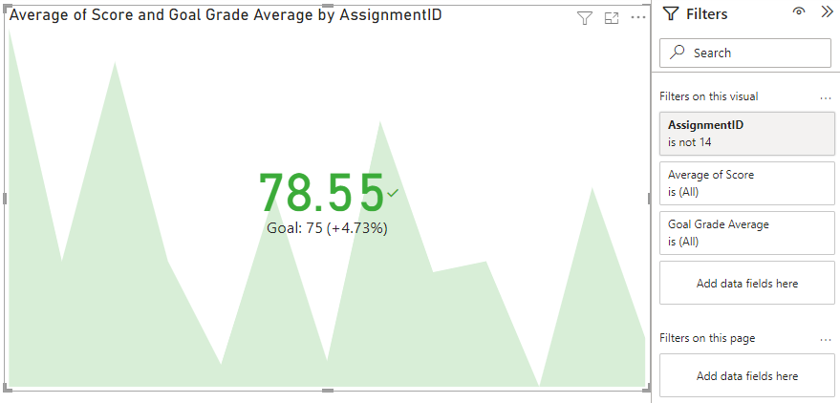
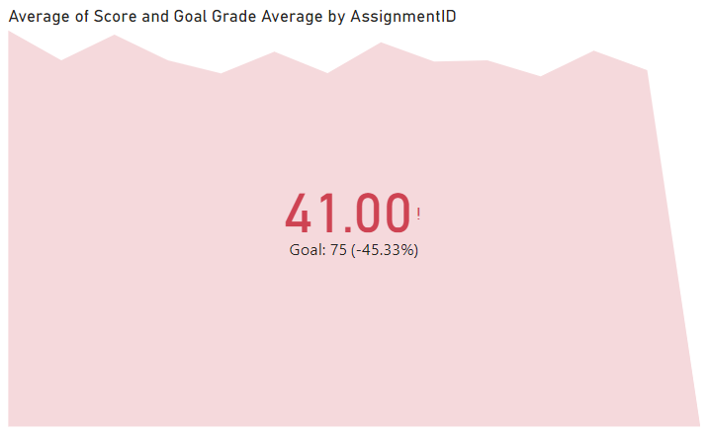
- Table/Matrix
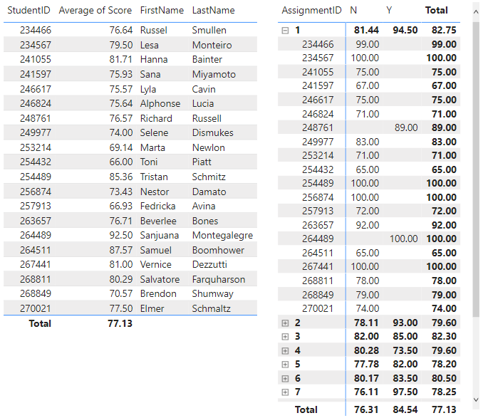
- Slicer
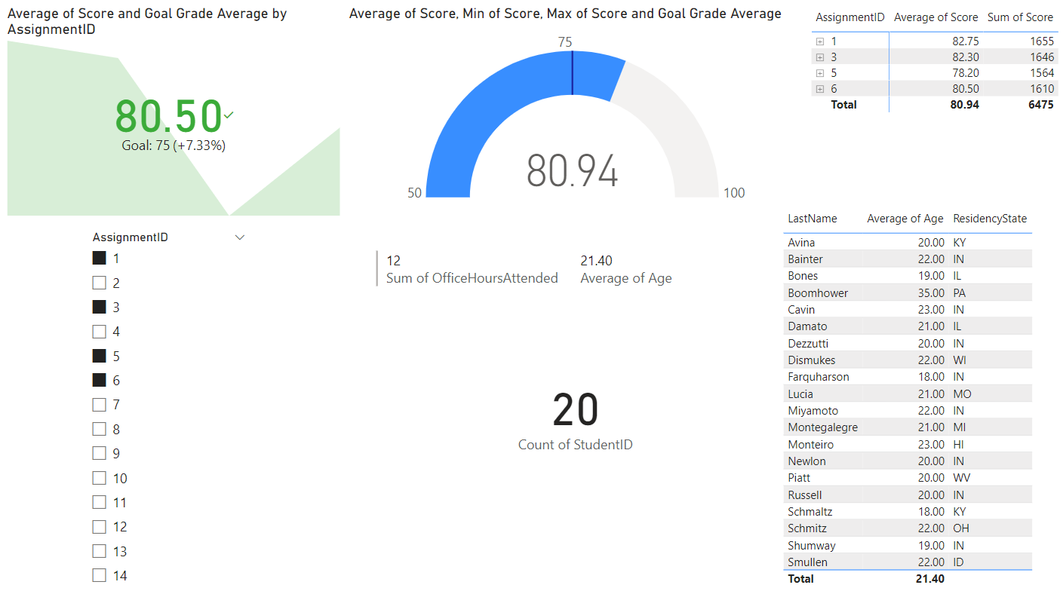

Aggregations, Measures, and DAX
- SUM
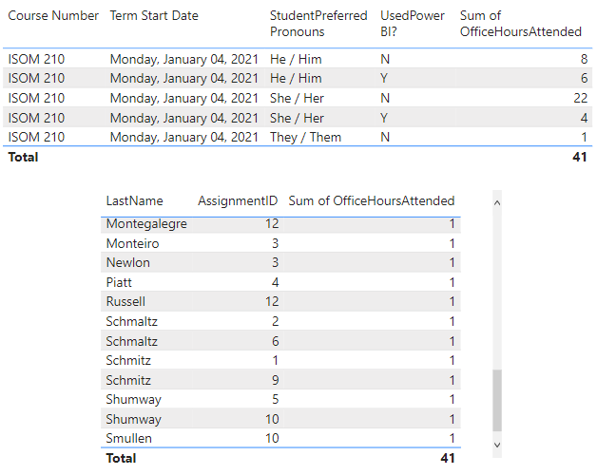
- AVERAGE
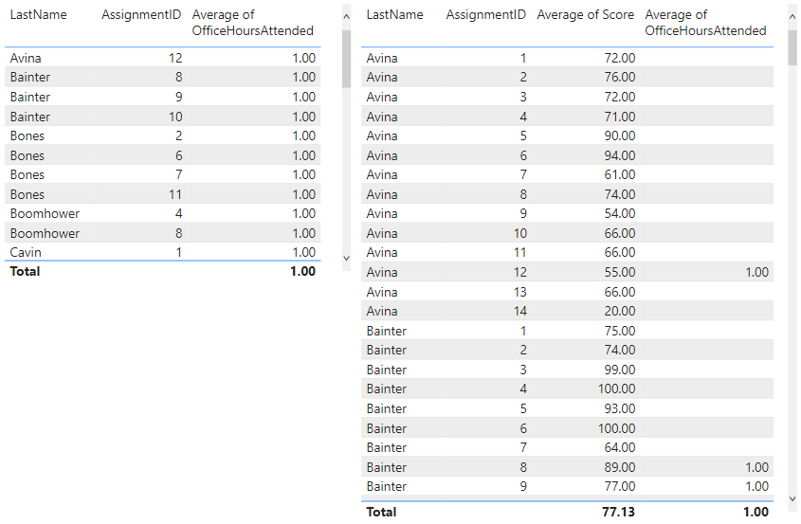
- Standard deviation, variance and median
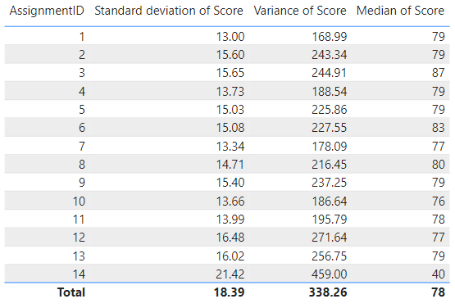
- Count and Count (distinct)
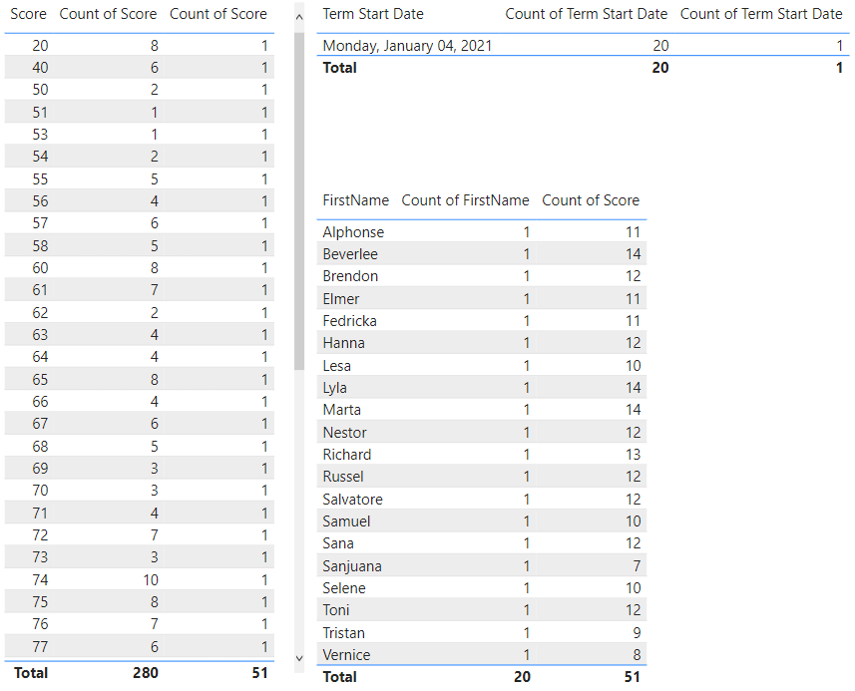
- First, last, earliest, and latest
